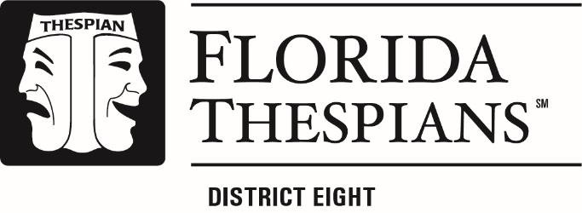

Sponsors,
RE: Thespian Troupe to the District 8 Thespians Festival, November 16th-19th
District 8 Thespians is proud to invite your affiliated Thespian Troupe to the District 8 Thespians Festival. The Festival includes the One Act Festival and the Individual Events Festival.
Join us on November 16-18 for the High School One Act Festival at Hialeah Senior High School (251 E 47th Street in Hialeah, Florida) and November 19th for the Individual Events Festival at Miami Airport Convention Center (711 NW 72nd Ave, Miami, FL 33126)
ONE ACT
10-40 MIN Play. Troupes will present a one-act play (original or published) fully realized. Set must fit in 6’X9’ Box and the play is not to exceed 40 min from “Wing to Box”
STATE RULES: https://floridathespians.com/one-act-rules/
INDIVIDUAL EVENTS
Scenes, Songs and Technical Events presented for assessment. The events include:
Monologue
Duet Acting
Ensemble Acting
Pantomime
Solo Musical
Duet Musical
Small Group Musical
Large Group Musical
Makeup Design
Costume Design
Costume Construction
Set Design
Publicity Design
Playwriting

STATE RULES: https://floridathespians.com/individual-event-rules/
REGISTRATION SITE: https://floridadist08.cothespians.net/authake/user/selection

SINCERELY,
DISTRICT 8 THESPIANS
WWW.DISTRICT8THESPIANS.COM

